**MORPHOLOGICAL OPERATION ON IMAGES**

clc;

clear all;

close all;

A=imread('C:\Users\Public\Pictures\Sample Pictures\bunny.jpg');

B = im2bw(A);

B = imresize(B,[700 700]);

[R,C] = size(B);

imshow(B);

% STRUCTURING ELEMENTS

%S1 = [1 1 1;1 1 1;1 1 1];

%S2 = [0 0 0;1 1 1;0 0 0];

for x = 2:R-1

for y = 2:C-1

a1 = [1*B(x-1,y-1) 1*B(x-1,y) 1*B(x-1,y+1) 1*B(x,y-1) 1*B(x,y) 1*B(x,y+1)...

1*B(x+1,y-1) 1*B(x+1,y) 1*B(x+1,y+1)];

a2 = [ B(x,y-1) B(x,y) B(x,y+1) ];

D1(x,y) = max(a1);

D2(x,y) = max(a2); % MAXIMUM VALUE OF PIXEL

E1(x,y) = min(a1);

E2(x,y) = min(a2); % MINIMUM VALUE OF PIXEL

end

end

%without functions

figure(1);

subplot(1,3,1);

imshow(A);

title('ORIGINAL IMAGE');

subplot(1,3,2);

imshow(D1);

title('DILATED witoutfunc ');

subplot(1,3,3);

imshow(E1);

title('ERODED witoutfunc');

% using functions

figure(2);

subplot(1,3,1);

imshow(A);

title('ORIGINAL IMAGE');

subplot(1,3,2);

D = imdilate(B,a1);

imshow(D);

title('DILATED inbuiltfunc ');

subplot(1,3,3);

E = imerode(B,a1);

imshow(E);

title('ERODED inbuiltfunc');

Edge = D2-E2;

figure

imshow(Edge);

%Closing and Opening images

E2 = imresize(E2,[700 700]);

D2 = imresize(D2,[700 700]);

[R,C] = size(E2);

o=E2;

c=D2;

for x = 2:R-1

for y = 2:C-1

ao = [1*o(x-1,y-1) 1*o(x-1,y) 1*o(x-1,y+1) 1*o(x,y-1) 1*o(x,y) 1*o(x,y+1)...

1*o(x+1,y-1) 1*o(x+1,y) 1*o(x+1,y+1)];

ac = [1*c(x-1,y-1) 1*c(x-1,y) 1*c(x-1,y+1) 1*c(x,y-1) 1*c(x,y) 1*c(x,y+1)...

1*c(x+1,y-1) 1*c(x+1,y) 1*c(x+1,y+1)];

O(x,y) = max(ao);

C(x,y) = min(ac);

end

end

figure

subplot(2,2,1);

imshow(O);

title('Opening witoutfunc');

subplot(2,2,2);

imshow(C);

title('Closing witoutfunc');

%Using inbuilt functions

se = strel('square',3);

Open = imopen(B,se);

subplot(2,2,3);

imshow(Open);

title('Opening by inbuilt Func');

Close = imclose(B,se);

subplot(2,2,4);

imshow(Close);

title('Closing by inbuilt Func');

output:

border of original image

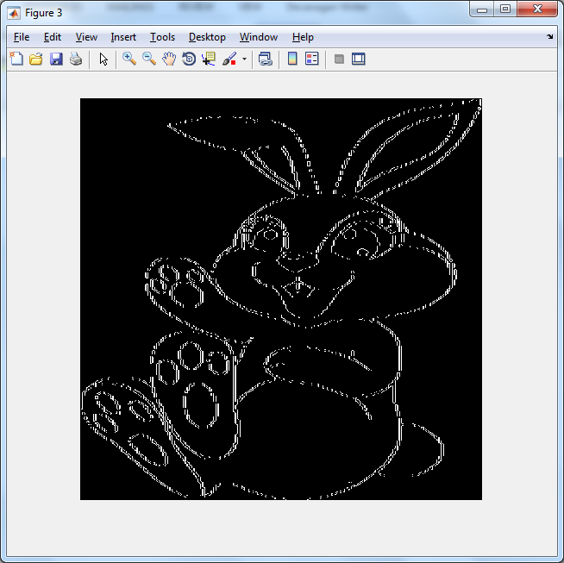

dilation and erosion of image using inbuilt function

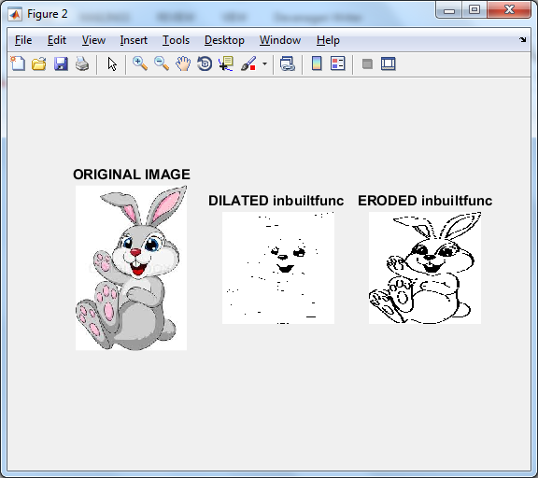

dilation and erosion of image without using inbuilt function

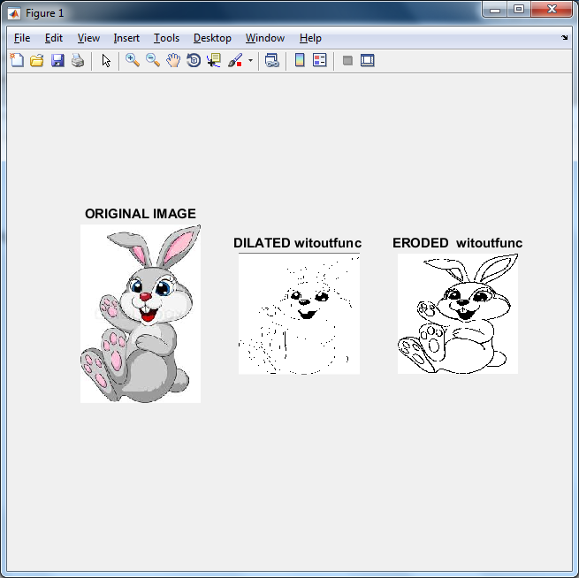

opening and closing of images inbuilt functions and without using inbuilt functions

